**FPS COUNTER BRIEF**

**BY SAMUEL PARSONS**

For the fps counter I started by creating a UI text by right clicking the hierarchy, then going to the UI section of the dropdown and finally clicking Text.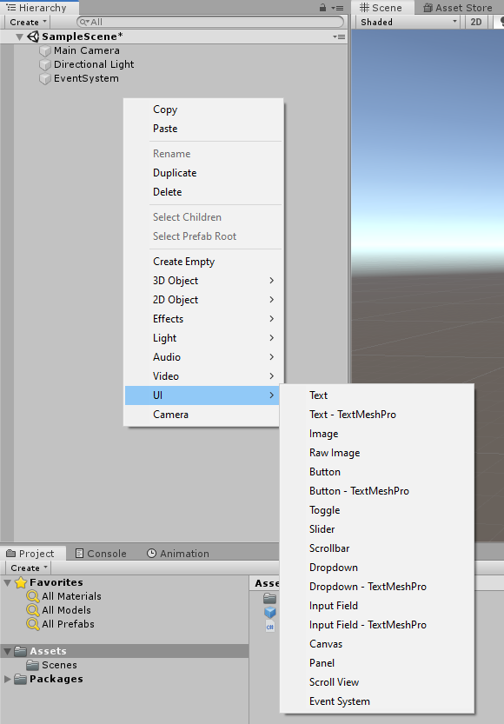

I then added a script to the text ui by clicking on add component in the inspector then finding the new script component.

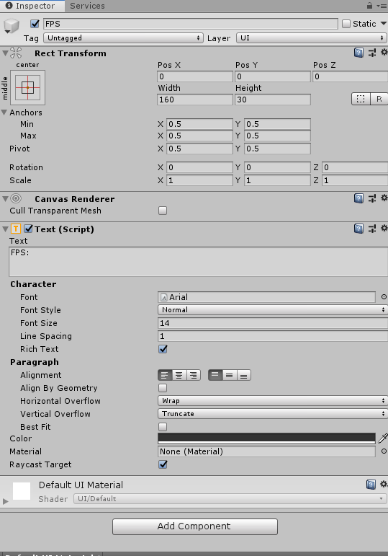



Once I had opened up the fresh script I began by adding *using UnityEngine.UI;* just underneath where it says *using UnityEngine. 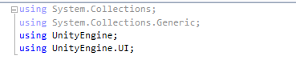*

I then created four variables that would be used through the code. I first created an integer variable called frameCount that would store how many frames are occurring per second I then set it to equal 0. Next I made two floats that would be named timeCounter and refreshTime, timeCounter which I set to equal 0 will be used to to count down before each recording is taken. The refreshTime which I set to equal 0.1 is the point at which the timeCounter will restart.

Lastly I made a GameObject variable called frText which will be used to reference the text object when I need to change what it says.

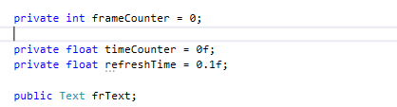

For the next section I used the void update function that was already with the script and created an if function which shall record when the timeCounter is less than the refreshTime. While the timeCounter’s value is less than the refreshTime value I will add to the timeCounter using *time.deltaTime* making it add the accurate amount of seconds, it will then also add 1 to the frameCounter as well for every frame it's below the refreshTime.

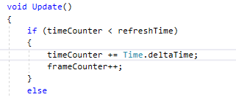

Lastly I will create an else function that will run every time the timer hits the refreshTime. In this else function I will add a new float variable which shall be called lastFramerate which will be equal to the frameCounter divided by the timeCounter, this will then give the frames for that .1 second multiplied by 10. I then reset both the frame and time counters to 0 and displayed the lastFramerate on the text GameObject by making its text say “Fps: “ for display purposes and then add *lastFramerate.ToString(“n0”);* this will turn the float into a string so that it may be placed next to the text as well as round up the variable to the closest round number.

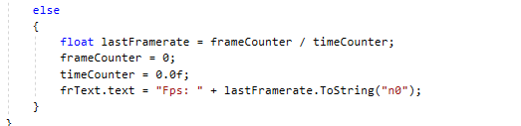

Now that has all been coded I saved and went back to the unity window. I then took the Framerate gameobject from the hierarchy and dragged it into the empty box in the script component on the Framerate gameobject.



Finally I repositioned the text object in my scene and pressed play